Inheritance

1. Inheritance allows you to create new objects that take on the properties of existing objects. A class that is used as a base for inheritance is called a super class or base class.
   1. TRUE
   2. False
2. The following syntax is used for ?

class Subclass-name extends Superclass-name

{

// methods and fields

}

* 1. Polymorphism
  2. encapsulation
  3. Inheritance
  4. None of the above

1. The abstract class can have
   1. abstract methods
   2. Methods with code implementation
   3. Used to create subclasses
   4. used to create objects
2. A class that inherits is called ?
   1. superclass
   2. subclass
   3. subset class
   4. relative class
3. Which of these can NOT be transmitted by inheritance?
   1. public variables
   2. private variables
   3. methods
   4. Data
4. Which of the following statements are true for inheritance in Java?
   1. You can extend various classes in Java.
   2. The private members of the superclass are accessible to the subclass.
   3. We cannot extend final classes in Java.
   4. extends " keyword is used to extend a class in Java.
5. What is an abstract method?
   1. An abstract method is any method in an abstract class.
   2. abstract keyword .
   3. An abstract method is a method that cannot be inherited.
   4. An abstract method is a method in the child class that overrides a parent method.
6. The IS-A (is a) relationship is based on inheritance and allows us to affirm that an object is of a specific type (class).
   1. TRUE
   2. False
7. Abstract classes serve as a blueprint for the creation of derived classes. Some characteristics of these are:
   1. They can contain abstract methods and concrete methods.
   2. May contain attributes .
   3. They can inherit from other classes.
8. In the following UML diagram: Is the object-oriented programming pillar (Inheritance ) represented?

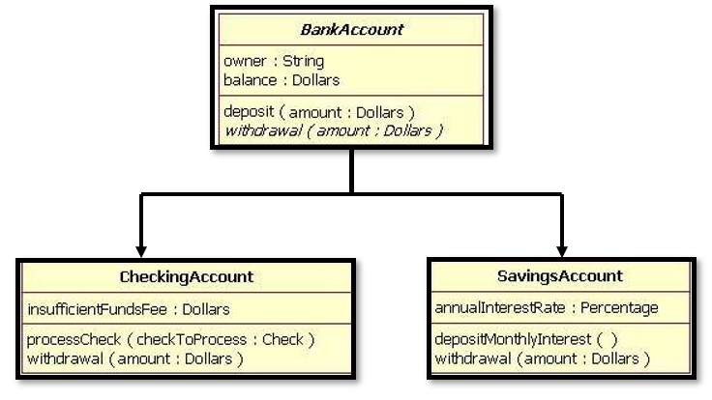

* 1. TRUE
  2. False